**Terraform Task**

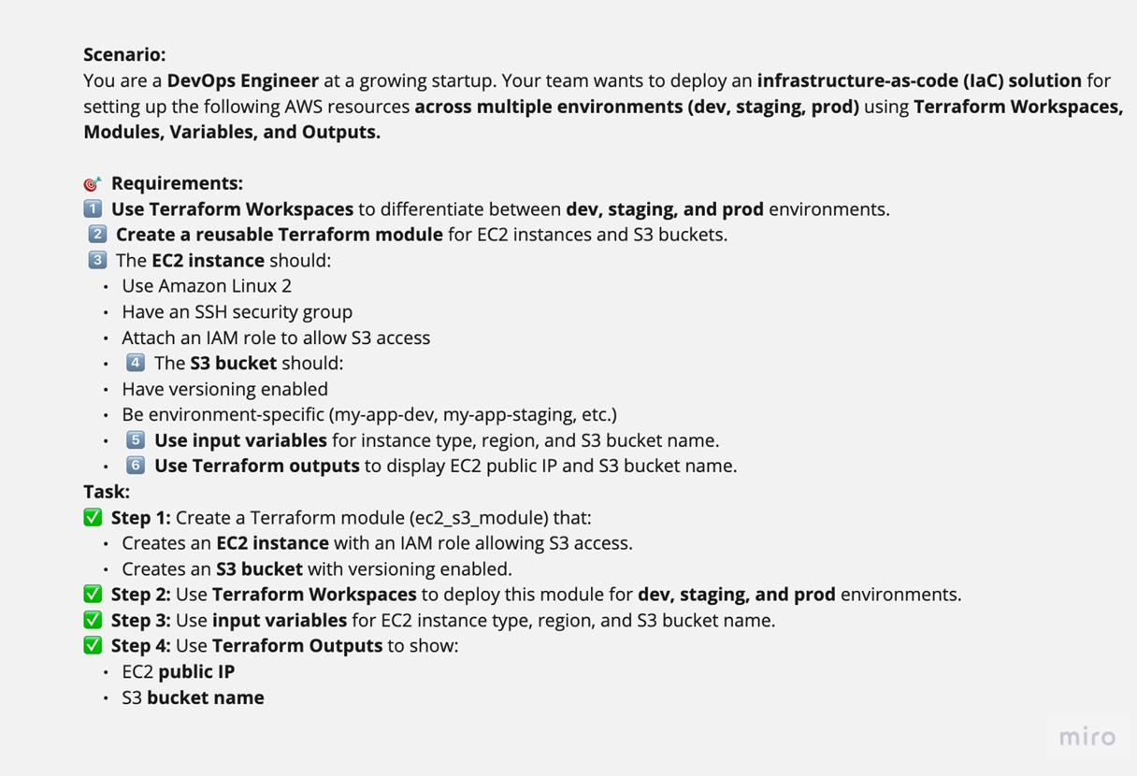

Explanation :

1. Create the folder named terraform. Create a subfolder modules and create main.tf file in it.

**Main.tf file**

terraform {

  required_providers {

    aws = {

      source  = "hashicorp/aws"

      version = "~> 5.0"

    }

  }

}

# Configure the AWS Provider

provider "aws" {

  region = var.aws_region

}

#ssh security group

resource "aws_security_group" "allow_ssh" {

  name        = "allow_ssh-${terraform.workspace}"

  description = "Allow ssh access"

}

resource "aws_vpc_security_group_ingress_rule" "ssh" {

  security_group_id = aws_security_group.allow_ssh.id

  cidr_ipv4         = "0.0.0.0/0"

  from_port         = 22

  ip_protocol       = "tcp"

  to_port           = 22

}

resource "aws_vpc_security_group_egress_rule" "allow_all_traffic_ipv4" {

  security_group_id = aws_security_group.allow_ssh.id

  cidr_ipv4         = "0.0.0.0/0"

  ip_protocol       = "-1" # semantically equivalent to all ports

}

# IAM role-aws_iam_role

resource "aws_iam_role" "s3_access" {

  name = "s3_access-${terraform.workspace}"

  # Terraform's "jsonencode" function converts a

  # Terraform expression result to valid JSON syntax.

  assume_role_policy = jsonencode({

    Version = "2012-10-17"

    Statement = [

      {

        Action = "sts:AssumeRole"

        Effect = "Allow"

        Principal = {

          Service = "ec2.amazonaws.com"

        }

      },

    ]

  })

}

# IAM role-aws_iam_role_policy_attachment

resource "aws_iam_role_policy_attachment" "s3_policy" {

  role       = aws_iam_role.s3_access.name

  policy_arn = "arn:aws:iam::aws:policy/AmazonS3FullAccess"

}

# IAM role-aws_iam_instance_profile

resource "aws_iam_instance_profile" "s3_profile" {

  name = "s3-profile-${terraform.workspace}"

  role = aws_iam_role.s3_access.name

}

#ec2 instance

resource "aws_instance" "ec2-instance" {

  ami                     = "ami-0c2e61fdcb5495691"

  instance_type           = var.instance_type

  key_name = var.ssh_key_name

  vpc_security_group_ids = [aws_security_group.allow_ssh.id]

  associate_public_ip_address = true

  iam_instance_profile   = aws_iam_instance_profile.s3_profile.name

}

#s3 bucket

resource "aws_s3_bucket" "my_s3" {

  bucket = "${var.s3_bucket_name}-${terraform.workspace}"

}

1. Create variable.tf under modules

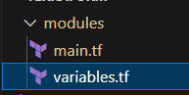

**Variable.tf file**

variable "aws_region" {

  description = "AWS region"

  type        = string

}

variable "instance_type" {

  description = "Instance type"

  type        = string

}

variable "ssh_key_name" {

  description = "SSH key name"

  type        = string

}

variable "s3_bucket_name" {

  description = "S3 bucket name"

  type        = string

}

1. **Create outputs.tf**

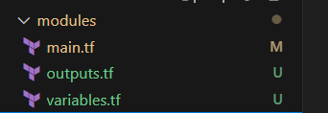

output "ec2_public_ip" {

value = aws_instance.ec2-instance.public_ip

}

output "s3_bucket_name" {

value = aws_s3_bucket.my_s3.id

}

1. Create main.tf in the root directory

**main.tf – root**

provider "aws" {

  region = var.aws_region

}

module "ec2-s3" {

  source          = "./modules"

  aws_region      = var.aws_region

  instance_type   = var.instance_type

  ssh_key_name    = var.ssh_key_name

  s3_bucket_name  = var.s3_bucket_name

}

output "ec2_public_ip" {

  value = module.ec2-s3.ec2_public_ip

}

output "s3_bucket_name" {

  value = module.ec2-s3.s3_bucket_name

}

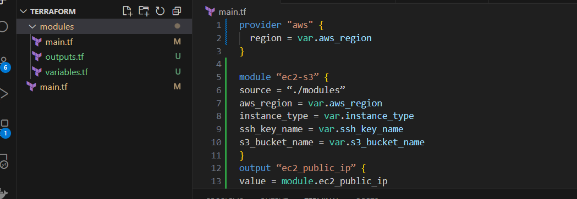

1. Create terra.tfvars in root directory

**Terrs.tfvars**

aws_region = "us-east-1"

instance_type = "t2.micro"

ssh_key_name = "Nivetha"

s3_bucket_name = "nivi-bucket1"

create variable.tf in root directory

variable "aws_region" {

description = "AWS region"

type = string

}

variable "instance_type" {

description = "Instance type"

type = string

}

variable "ssh_key_name" {

description = "SSH key name"

type = string

}

variable "s3_bucket_name" {

description = "S3 bucket name"

type = string

}

1. Create workspaces using the bellow commands

Terraform init

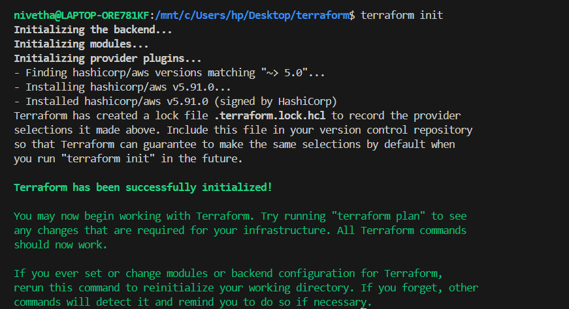

terraform workspace new dev

terraform workspace new prod

terraform workspace new staging

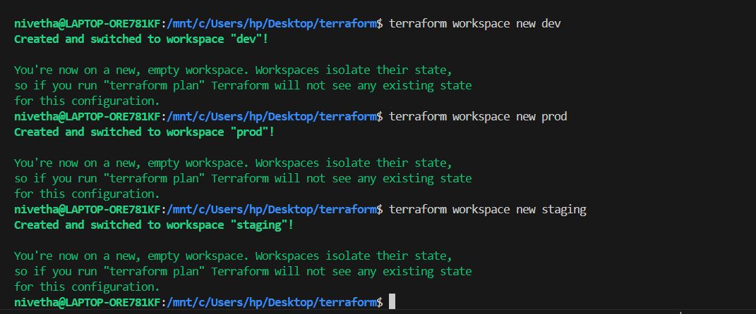

Terraform workspace list

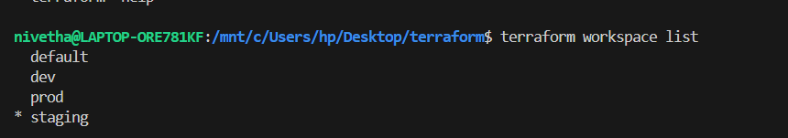

terraform workspace select dev



terraform apply

